CAREER ASSESSMENT

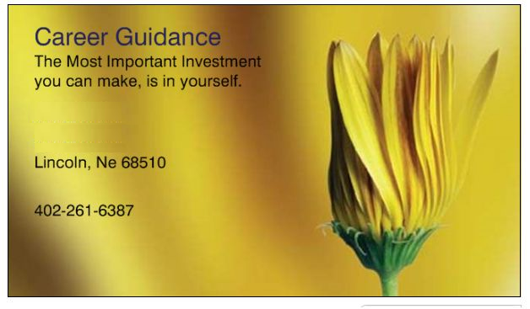

- #1 Motivator for a person is their interest of their Heart
- It is also their #1 Predictability of success. – For that Person ^{*ref 1}
- So if you wish to move a in a direction for Successs– then you seek this information.

Career Guidance staff has had over 35 years experience in the field … so if you would like us to Guide you in the right direction, we would be glad to.

*1 Such things as : Personality, Grades in School, Aptitudes, IQ are NOT predictabilities of Success.

CAREER GUIDANCE - New Directions

Uniquely Qualified in Sorting out ASSESSMENT issues.

Our staff has represented most of the Colleges & Universities surrounding the 15 County area of Nebraska Capital for Job Training. All applicants had to receive our testing.

Also reviewed all contracts for the Private Industry Council regarding Training & did all of the Testing for those individuals.

We followed the individuals before, during and After Training.
In Research circles, this is called Longitudinal Studies.

Our Staff has done Career Assessment since 1975.

We are Specialized in this Field.

